**DAILY ONLINE ACTIVITIES SUMMARY**

|  |  |  |  |  |  |  |  |  |
| --- | --- | --- | --- | --- | --- | --- | --- | --- |
| **Date:** | **31/05/2020** | | | | | **Name:** | **NAIPUNYA VINOD NAIK** | |
| **Sem & Sec** | **IV SEM & A SECTION** | | | | | **USN:** | **4AL18CS050** | |
| **Online Test Summary** | | | | | | | | |
| **Subject** | | **NO TEST CONDUCTED** | | | | | | |
| **Max. Marks** | | **NIL** | | **Score** | | | **NIL** | |
| **Certification Course Summary** | | | | | | | | |
| **Course** | **INTRODUCTION TO CYBER SECURITY** | | | | | | | |
| **Certificate Provider** | | | **GREAT**  **LEARNING ACADEMY** | | **Duration** | | | **7 HRS** |
| **Coding Challenges** | | | | | | | | |
| **Problem Statement:** [Write a Java program to calculate nPr.](https://github.com/orgs/alvas-education-foundation/teams/2nd-year/discussions/89) | | | | | | | | |
| **Status: EXECUTED** | | | | | | | | |
| **Uploaded the report in Github** | | | | | **YES** | | | |
| **If yes Repository name** | | | | | <https://github.com/naipunya-naik/lockdown-coding/blob/master/JAVA%20CODING/npr_31-05-2020.java> | | | |
| **Uploaded the report in slack** | | | | | **YES** | | | |

Online Test Details: (Attach the snapshot and briefly write the report for the same)

NO TEST WAS CONDUCTED.

Certification Course Details: (Attach the snapshot and briefly write the report for the same).

CERTIFICATION COURSE NAME:- INTRODUCTION TO CYBERSECURITY

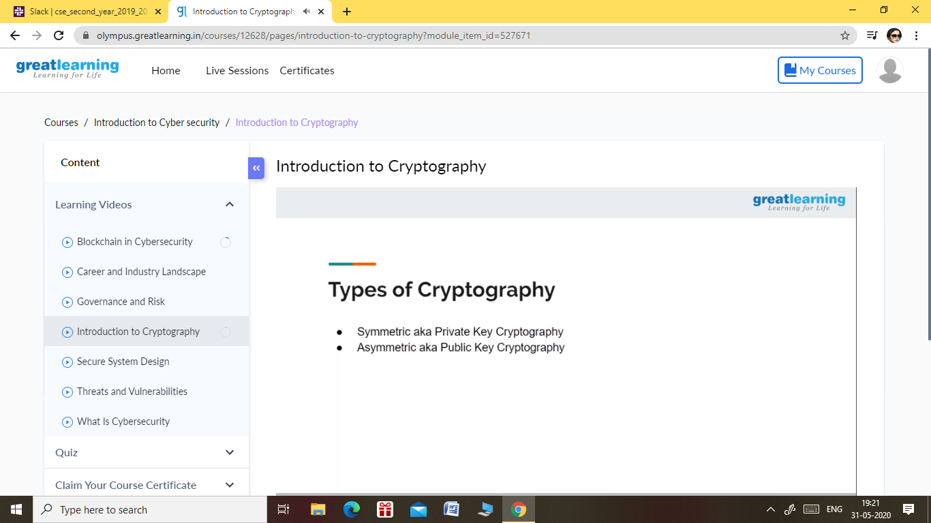

* TODAY I STARTED A NEW COURSE OF INTRODUCTION TO CYBER SECURITY ON GREATLY LEARNING ACADEMY.
* PREVIOUSLY ,I WAS DOING A COURSE ON INTRODUCTION TO CLOUD , BUT TODAY THEIR WEBSITE HAD SERVER PROBLEM SO I DISCONTINUED THAT COURSE,IF THEIR SERVER BECOMES PROPER I WILL RESUME THAT COURSE SOON.
* TOPICS LEARNT ON 31 MAY 2020:-
* BLOCKCHAIN IN CYBERSECURITY
* CAREER AND INDUSTRY LANDSCAPE
* GOVERNANCE AND RISK
* INTRODUCTION TO CRYPTOGRAPHY

Coding Challenges Details: (Attach the snapshot and briefly write the report for the same)

PROBLEM STATEMENT:- [Write a Java program to calculate nPr.](https://github.com/orgs/alvas-education-foundation/teams/2nd-year/discussions/89) **nPr** represents n permutation r and value of nPr is **(n!) / (n-r)!.**

**Input:**  
The first line of the input contains **T** denoting the number of testcases. T testcases follow. First line of the test case will be the value of n and r respectively.

Output:  
For each test case, in a new line, output will be the value of nPr.

Constraints:  
**1 <= T <= 100  
1 <= n,r <= 20  
n >= r**

**Example:**  
Input:  
2  
2 1  
10 4  
Output:  
2  
5040

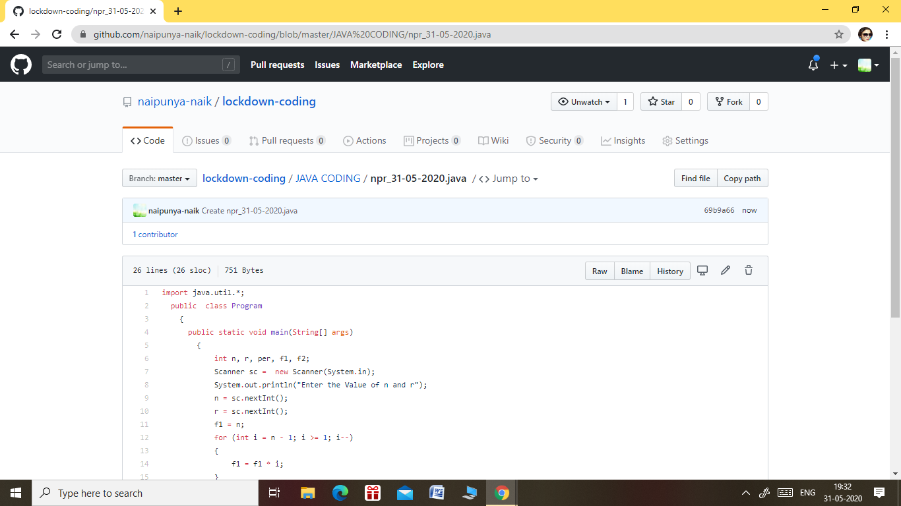

GITHUB REPOSITORY LINK:-

<https://github.com/naipunya-naik/lockdown-coding/blob/master/JAVA%20CODING/npr_31-05-2020.java>